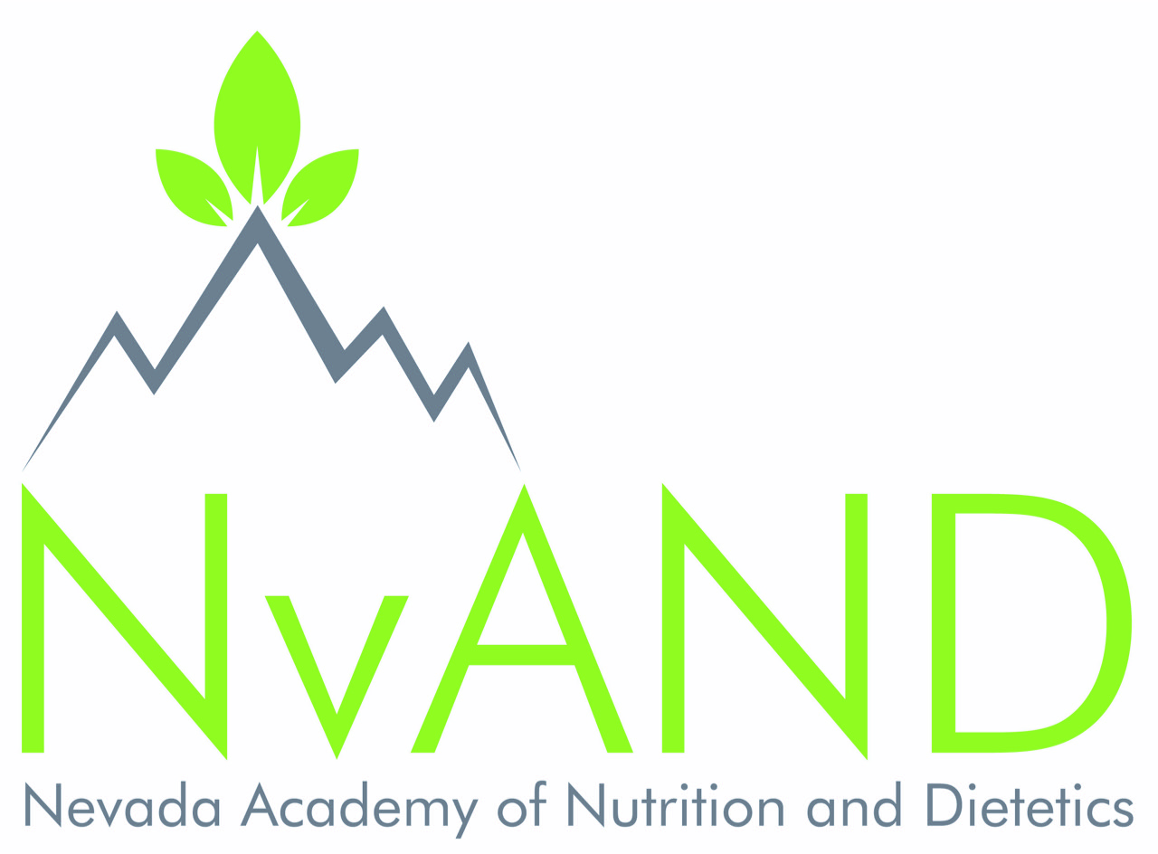
SPONSORSHIP PROSPECTUS

2019 NvAND Annual Meeting
April 12, 2019, Renown Medical Center, Reno NV

The NvAND (Nevada Academy of Nutrition and Dietetics) is an affiliate of the Academy of Nutrition and Dietetics the world’s largest organization of food and nutrition professionals. The Nevada Academy of Nutrition and Dietetics and the National Academy are committed to improving the nation’s health and advancing the profession of dietetics through research, education and advocacy.

The NvAND’s efforts are enhanced through grants and support from industry and organizations with similar goals and vision. Please consider supporting our organization in any of the following ways:

Sponsorship Opportunities

Sponsored Meals and Refreshments:

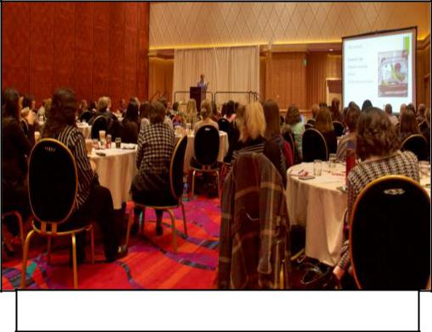
Please place a check mark next to the meal or break your company/organization would like to Sponsor:

- Lunch: $5,500 (Elite Level)
- Breakfast: $3,500 (Elite Level)
- Refreshment Break: $1,000 (Gold Level)

- Public recognition during announcements

- Display of your promotional materials during meal or at refreshment table

- Opportunity to include your food/beverage product on menu for sponsored meal, break or reception (enough for ~150 attendees).
- Addition of company/organization logo on all marketing materials

- Additional benefits in chart that correlate with your sponsorship level

Educational Session Sponsorship:
Please place a check mark next to the type of session your company/organization would like to Sponsor:

- Keynote: $3,500 (Elite)

- Regular Session: $2,500 (Platinum)

- Sponsor a Speaker: Specify Amount $______________

Sponsorship Benefits listed in boxes below
- Sponsorship to cover Honorarium, travel, and accommodations for speaker.

- Public recognition during morning announcements and before sponsored session. Addition of company logo on all marketing material.

Sponsor Levels

Elite: $3,500 or More

Headline placement of Company logo and preferred corporate identity in NvAND’s printed materials, e-mail blasts and on NvAND website.
- Vendor booth with 1 draped table and two chairs and volunteer if needed

- NvAND registration bag insert opportunity (distributed to NvAND registrants only)
- Advertisement and company logo running NvAND meeting room; open throughout entire symposium Two free registration valued at $538 (includes: breakfast, snacks & lunch)

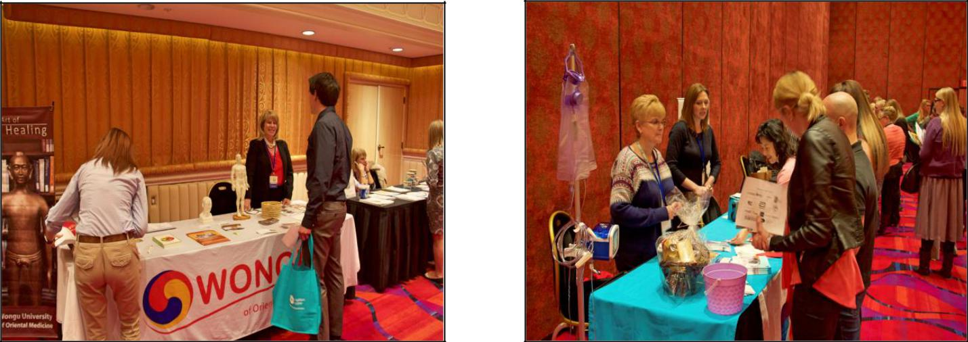

Platinum: $2,500-$3,500
Placement of Company logo under Platinum Sponsorship and preferred corporate

    - Identity in NvAND printed materials, email blasts, and on NvAND website.
- Vendor booth with 1 draped table and two chairs and volunteer if needed

- NvAND registration bag insert opportunity (distributed to NvAND registrants only)
- Slide show honoring sponsors in NvAND meeting room; open throughout entire symposium
- Two free registration valued at $538 (includes: breakfast, snacks & lunch)

Gold: $1,000-$2,500
Placement of Company logo under Platinum Sponsorship and preferred corporate

- Identity in NvAND printed materials, email blasts, and on NvAND website.
- Vendor booth with 1 draped table and two chairs

- NvAND registration bag insert opportunity (distributed to NvAND registrants only)
- Slide show honoring sponsors in NvAND meeting room; open throughout entire symposium
- One free registration valued at $269 (includes: breakfast, snacks & lunch)

Silver: $600-$1,000
Placement of Company logo under Silver Sponsorship and preferred corporate identity in NvAND print materials, email blasts and on NvAND website.
- Vendor booth with 1 draped table and two chairs
- NvAND registration bag insert opportunity (distributed to NvAND registrants only)
- Slide show honoring sponsors in NvAND meeting room; open throughout entire symposium
- Student scholarship winner will be available to represent company in order to save company the costs of flying someone in.

Check our website at http://www.eatrightnevada.org/ for Annual Conference Schedule and Events.
Updates Coming Soon!

For Non-profit Organizations, DPGS, and NV AND Member- Owned Businesses please inquire about additional sponsorship opportunities: nevadard@gmail.com

Auction Items:

We are also accepting donations for the Nevada of Academy of Nutrition and Dietetics’ annual raffle & silent auction which helps to provide scholarship opportunities for dietetic students going to school in Nevada.
(e.g. Gift Certificates, Tickets, Books, Merchandise, Products, etc.)

Please send any items to:
Jake Yarberry RDN LD (2018-2019 President)

822 Anchor Dr.
Henderson, NV 89015

Or
Email: annualmeeting@EatRightNevada.org

Nevada Academy of Nutrition and Dietetics
Sponsorship Application
- Please return completed application by mail with check by Friday, January 18, 2019
- OR apply online and pay via PayPal at: www.eatrightnevada.org and click link for 2019 NvAND Meeting
- Please find below the Sponsorship Application for the 2019 Nevada Academy of Nutrition and Dietetics’ Annual Meeting. Kindly fill out the application and return it to address above. Should you have any questions in the meantime, please:
  - Call Jake Yarberry RDN CPT, NvAND President at (775) 223-7566 OR Laura Kruskall, PhD, RDN, CAAD, LD, FACSM, FAND, Annual Meeting Chair at (702) 274-0370
OR
  - Email at: annualmeeting@EatRightNevada.org

Thank you!
Check our website at http://www.eatrightnevada.org/ for Annual Conference Schedule and Events.
Updates Coming Soon!

SPONSORSHIP CONTRACT

NvAND will provide the services as listed above in the chosen category.

- Elite Sponsor ($3,500 or More). Choice: $_______________
- Platinum Sponsor ($2,500-3,499). Choice: $_____________
- Gold Sponsor ($1000-2,499). Choice: $__________________

Payment must be received in full by Friday, January 18, 2019.

Company/Organization Name: Click here to enter text.

Contact Name: Click here to enter text.

Email:Click here to enter text. Phone: Click here to enter text.

Company Address: Click here to enter text.

Elite or Platinum Sponsors include additional name: Click here to enter text.

PAYMENT METHOD
- Check for $ enclosed, make check payable to: NvAND (Nevada Academy of Nutrition and Dietetics)
- Mail check to:
  - NvAND Treasurer
  - Geetha Krishnan
  - 8062 Minots Ledge Ave
  - Las Vegas, NV 89147
Henderson, NV 89015

Authorized Signature: ________________________________________________________

Printed Name and Title: Click here to enter text.

AUTHORIZATION

By signing this Agreement, I agree that I have read the above guidelines, and agree to abide by the terms and conditions set forth. A Sponsorship Application must be signed in order to confirm sponsorship of item.

CANCELLATION POLICY

No refunds due to sponsorship cancellation will be granted. Sponsor will be obligated to pay any outstanding balance due on sponsorship as outlined in the sponsor application/contract.
Check our website at http://www.eatrightnevada.org/ for Annual Conference Schedule and Events.
Updates Coming Soon!

